 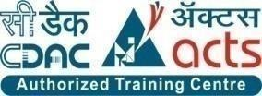

INSTITUTE FOR ADVANCED COMPUTING AND SOFTWARE DEVELOPMENT AKURDI, PUNE

Documentation On

“AgroKart”- Online Web Application, Agricultural Equipments, Seeds And Fertilizers Store.

PG-DAC SEPT 2022

**Submitted By:**

**Group No: 93**

**Roll No. Name:**

**229198 Sagar Ashtekar**

**229209 Ajit Shityalkar**

**Mr. Rohit Puranik Mrs. Monika Jadhav**

**Centre Coordinator Project Guide**

# ABSTRACT

This project is a web-based application system for selling agricultural equipments, fertilizers and seeds . The project objective is to deliver the online shopping application into web platform.

This project is an attempt to provide the advantages of online shopping to Customers­ of a real shop. It helps buying the products in the shop anywhere through internet by using a website device. Thus, the Customer will get the service of online shopping and home delivery from his favorite shop. This system can be implemented to any shop in the locality or to multinational branded shops having retail outlet chains.

If AgroKart is providing an online portal where their Customers can enjoy easy shopping from anywhere, the portal won’t be losing any more Customers to the Local Retail Outlets. Since this application is available in the Web it is easily as well as always available.

# ACKNOWLEDGEMENT

I take this occasion to thank God, almighty for blessing us with his grace and taking our endeavor to a successful culmination. I extend my sincere and heartfelt thanks to our esteemed guide, **Mrs. Monika Jadhav** for providing me with the right guidance and advice at the crucial juncture sand for showing me the right way. I extend my sincere thanks to our respected **Centre Co-Ordinator Mr. Rohit Puranik**, for allowing us to use the facilities available. I would like to thank the other faculty members also, at this occasion. Last but not the least, I would like to thank my friends and family for the support and encouragement they have given me during the course of our work.

**Sagar Ashtekar (229198)**

**Ajit Shityalkar (229209)**

**Table of Contents**

**1. Introduction 4**

1.1 Document Purpose **4**

1.2 Project Background **4**

1.3 Aim & Objectives **4**

**2. Business Requirements Overview**…………………………………………………………**5**

**3.Functional Requirements** **6**

3.1 Seller Module **6**

3.2 Buyer Module **6**

3.3 Admin Module **6**

**4.** **Non-Functional Requirement………………………………………………………………7**

**5. Use Case Diagram 8**

5.1 Admin **9**

5.2 Seller **10**

5.3 Buyer **11**

**6. Database Design 12**

1 User **12**

2 Roles **12**

3 Product……………………………………………………………………………………**13**

4 Payment Mode **13**

5 Order **13**

6 Order Details **13**

7 Category **13**

8 Cart **13**

9 Address **14**

**7. Snapshots 15**

**8. Conclusion 20**

**List of Figures**

**Use Case Diagrams 17**

Fig 1 Admin 8

Fig 2 Retailer 9

Fig 3 Customer 10

**LIST OF FIGURES**

**FIGURE 1: CUSTOMER ACTIVITY DIAGRAM 11**

**FIGURE 2: RETAILER ACTIVITY DIAGRAM 15**

**FIGURE 3: ADMIN ACTIVITY DIAGRAM 17**

**FIGURE 4: 1 LEVEL DFD FOR ADMIN 28**

**FIGURE 5: 1 LEVEL DFD FOR CUSTOMER 29**

**FIGURE 6: E-R DIAGRAM 30**

**FIGURE 7: CLASS DIAGRAM 31**

**FIGURE 8: TABLE STRUCTURE 32**

**FIGURE 9 : PROJECT DIAGRAMS 37**

# INTRODUCTION

This project is a web-based application system for selling agricultural equipments, fertilizers and seeds. An Online Shopping Management System where the Admin can Add, Update and Delete products. The Products are divided into various categories agricultural equipments, fertilizers and seeds . A user can select a particular item to view the details, choose the number of items and fill in details like Name, Address, etc. to buy a product, the project objective is to deliver the online shopping application into web platform. Online shopping is the process whereby consumers directly buy goods or services from a retailer in real- time, without an intermediary service, over the Internet. It is a form of electronic commerce. This project is attempts provide the advantages of online shopping to Customers of a real shop. It helps buying the products in the shop anywhere through internet by using the web application.

The objective of the project is to make an application on web-based platform to purchase items from online portal. In order to build such an application complete web support, need to be provided. A complete and efficient web application which can provide the online shopping experience is the basic objective of the project.

**Features:** -

1. Products Available- Agricultural Equipments, Fertilizers And Seeds
2. Search for seeds , fertilizers (Rice, Wheat,Urea) products easily
3. Category of products- Agricultural Equipments, Fertilizers And Seeds
4. Cart feature
5. Date and time of product delivery will be notified by the system
6. The admin can add/delete Suppliers and delivery boys.
7. Allows the Customers to maintain cart.

## 1.0 Aim & Objectives:

The main objective of this project is building a website which will help farmers from Indian rural area as well as urban areas to buy their required products with variety of range at affordable prices. System will also help local wholesalers or manufacturers to register and sell their products on our AgroKart. Hence variety of products can reach to farmer on their fingertips. In short wholesalers, manufactures, farmers, customers will be benefitted by the system.

System will also provide a feature which will give information about modern farming techniques and new innovations in agricultural fields helping farmers to improve their productivity.

* 1. **Business Requirements Overview:**
* AgroKart System is the public web application.
* AgroKart System will be opened to the global, but in the phase 1, the main target is in the India.
* There are mainly two types of users. One is the retailer and other is Customer.
* Customers can search for the market values of related agro products.
* Customers can search for the products available in the market and even the information about the productive farming.
* Retailers can add their products, stock availability, prices, specifications of products on the application.
* AgroKart System provides the functions which connect the farmers and the wholesaler efficiently.
* AgroKart System could be maintained by Administrator.

# 1.2 Functional Requirements Overview:

**AgroKart** System consists of three modules described as below.

1. Customer Module
2. Retailer Module
3. Admin Module

# 

# **1.3 Customer Module**

* Customer can register and create his own account.
* **AgroKart** System provides the function which allows Customer to search and buy their required products.
* Customer can browse existing market price and can compare them.

# **1.4 Retailer Module**

* Retailer can register and create his own account.
* **AgroKart** System provides the function which allows Retailer user to add their Argo products on to the application.
* Retailer can browse the products.
* Retailer can delete their products from application.
* Retailer can update the information of the products.

## 1.5 Admin Module

* **AgroKart** System should provide all function to admin how to handle the System.
* will know all the Transaction.
* can add category.
* can view all user and delete specific user.
* Will generate report.

# 

# 2 Non-Functional Requirement:

* The website should use professional design, look and feel and color scheme.
* Users will have no limitations for accessing the application through Internet. The portal being an internet application, it is difficult specify exact number of visitor or users. Hence we will target the system to support between 5 and 10 million users on launch of phase 1.
* Being a public website, the site must follow general usability guidelines for menus, navigation, colors, links and other actions provided on the screens.
* The system should be designed in such a manner that user will be able to complete tasks in minimum number of steps.

# 3. Use-Case Diagram

**3.1 Admin:** –



## 3.2 Retailer:-



**3.3 Customer:**



**ER DIAGRAM**

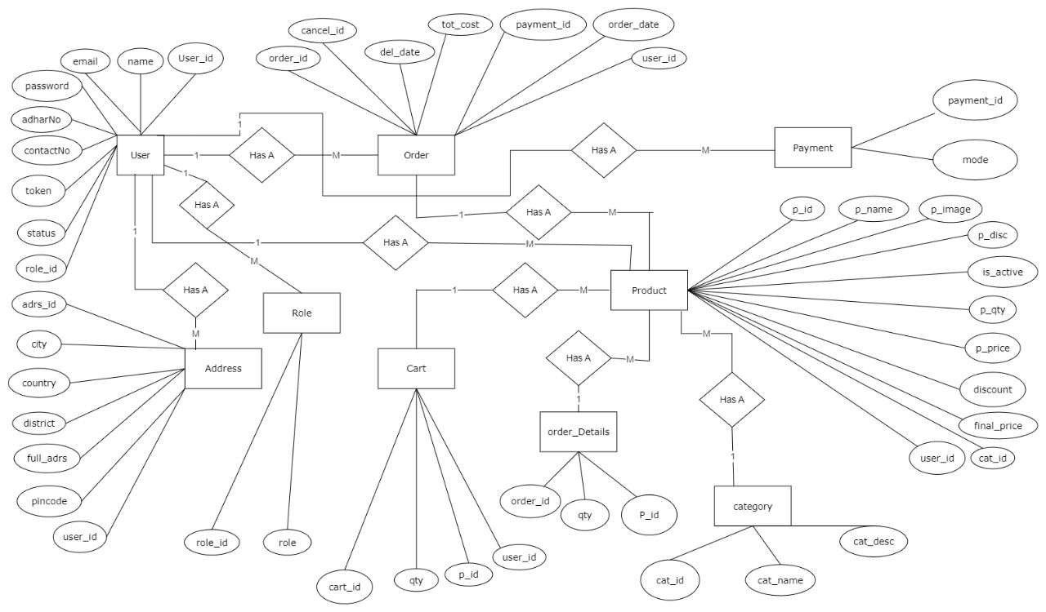

**E-R Diagram(MySQL Auto generated)**

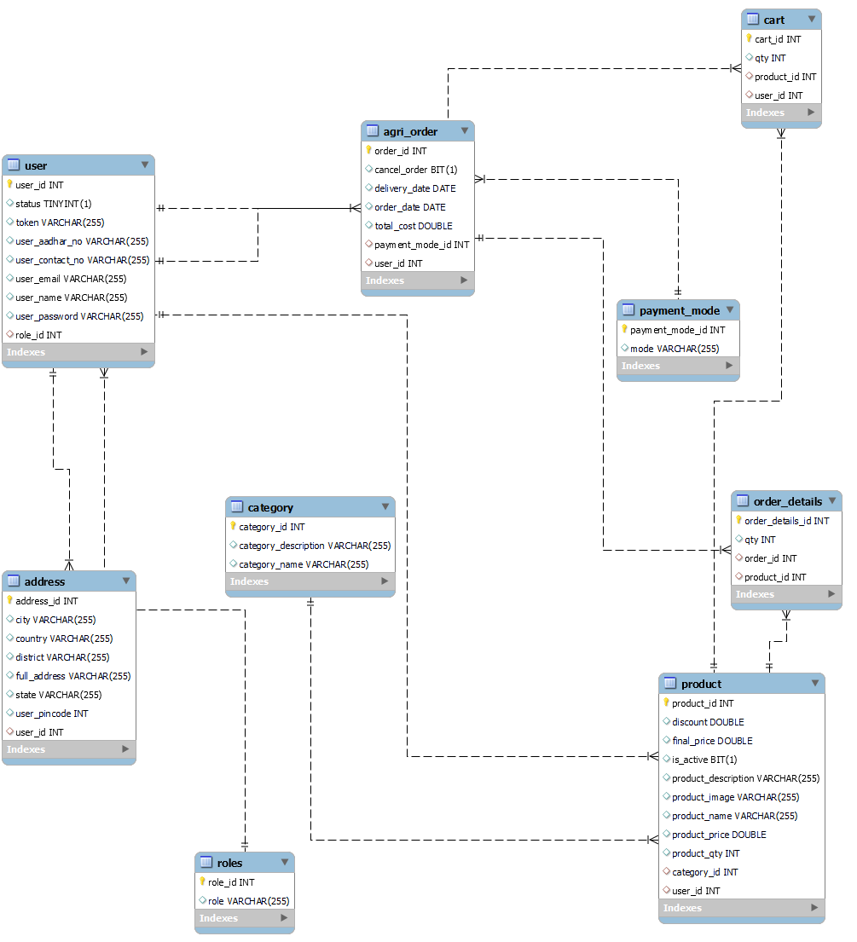

**Data Flow Diagram**

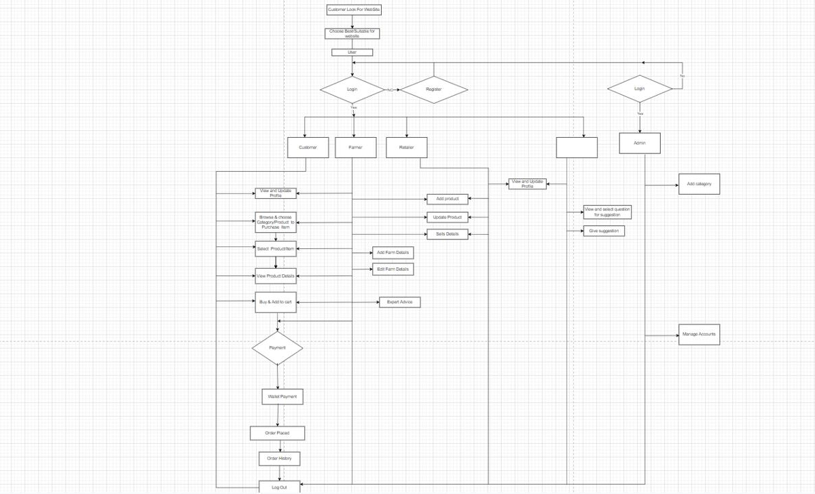

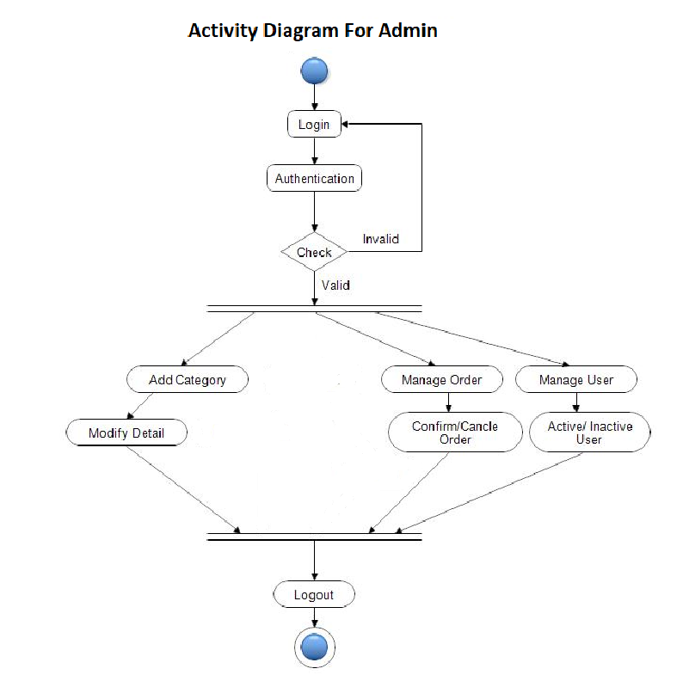

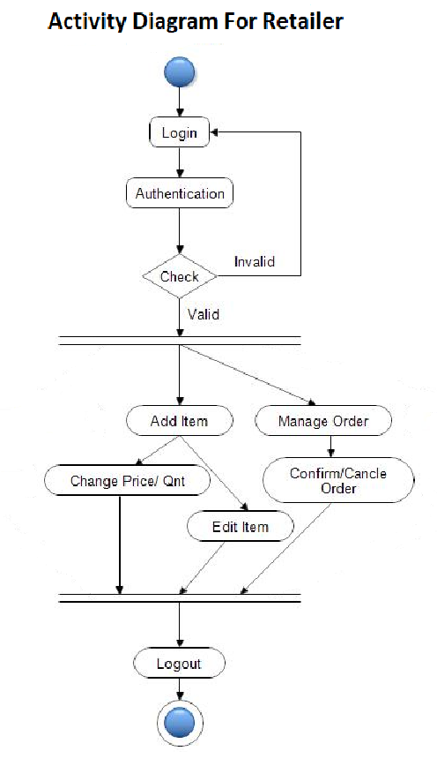

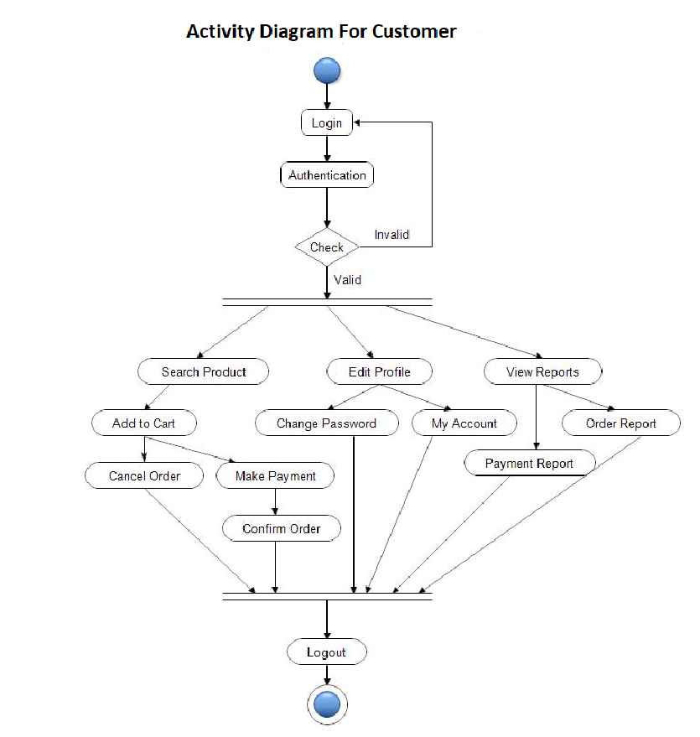

**6. Database Design:**

**1] User table**

|  |  |  |  |  |  |
| --- | --- | --- | --- | --- | --- |
| **Field** | **Type** | **Null** | **Key** | **Default** | **Description** |
| user_id | Int | No | PK | AI | User ID |
| status | Boolean | No |  |  | User Status |
| user_aadhar_no | Int | No |  |  | Aadhaar Number |
| user_contact_no | Int | No |  |  | Contact Number |
| user_email | Varchar(45) | No |  |  | Emailid |
| user_name | Varchar(45) | No |  |  | User name |
| user_password | Varchar(45) | No |  |  | Password |
| role_id | Int | No |  |  | User role |

**2] Product table**

|  |  |  |  |  |  |
| --- | --- | --- | --- | --- | --- |
| **Field** | **Type** | **Null** | **Key** | **Default** | **Description** |
| product_id | Int | No | PK | AI | Product ID |
| discount | Double |  |  |  | Product Discount |
| final_price | Double | No |  |  | Product Final Price |
| product_description | Varchar(45) | No |  |  | Product description |
| product_image | Varchar(45) | No |  |  | Product Image |
| product_name | Varchar(45) | No |  |  | Product name |
| product_qty | Int | No |  |  | Product Quantity |
| category_id | Int | No | FK |  | Product Category |
| user_id | Int | No | Fk |  | User ID |

**3] Order table**

|  |  |  |  |  |  |
| --- | --- | --- | --- | --- | --- |
| **Field** | **Type** | **Null** | **Key** | **Default** | **Description** |
| order_id | Int | No | PK | AI | Order ID |
| cancel_order | Boolean | No | FK |  | Order Cancel |
| deliver_date | Date | No |  |  | Delivery date |
| order_date | Date | No |  |  | Order Date |
| total_ammount | Double | No |  |  | Total Amount |
| payment_mode_id | Int | No |  |  | Payment Mode |
| user_id | Int | No | FK |  | User ID |

**4] Address table**

|  |  |  |  |  |  |
| --- | --- | --- | --- | --- | --- |
| **Field** | **Type** | **Null** | **Key** | **Default** | **Description** |
| address_id | Int | No | PK |  | User Address ID |
| City | Varchar(45) | No |  |  | User Address |
| country | Varchar(45) | No |  |  | User Address |
| district | Varchar(45) | No |  |  | User Address |
| state | Varchar(45) | No |  |  | User Address |
| full_address | Varchar(200) | No |  |  | User Address |
| user_pincode | Int | No |  |  | User Address |
| user_id | Int | No | FK |  | User ID |

**5] Cart table**

|  |  |  |  |  |  |
| --- | --- | --- | --- | --- | --- |
| **Field** | **Type** | **Null** | **Key** | **Default** | **Description** |
| cart_id | Int | No | PK | AI | Cart ID |
| Qty | Int | No |  |  | Product identity |
| product_id | Int | No | FK |  | Product ID |
| User_id | Int | No | FK |  | User ID |

**6] Category table**

|  |  |  |  |  |  |
| --- | --- | --- | --- | --- | --- |
| **Field** | **Type** | **Null** | **Key** | **Default** | **Description** |
| category_id | Int | No | PK | AI | Category ID |
| category_name | Varchar(45) |  |  |  | Category Name |

**7] Order_details table**

|  |  |  |  |  |  |
| --- | --- | --- | --- | --- | --- |
| **Field** | **Type** | **Null** | **Key** | **Default** | **Description** |
| order_details_id | Int | No | PK | AI | Order Details ID |
| Qty | Int | No |  |  | Total Product Quantity |
| order_id | Int | No | FK |  | Order ID |

**8] Payment_mode table**

|  |  |  |  |  |  |
| --- | --- | --- | --- | --- | --- |
| **Field** | **Type** | **Null** | **Key** | **Default** | **Description** |
| payment_mode_id | Int | No | PK | AI | Payment ID |
| Mode | Varchar(45) | No |  |  | Payment Mode |

**9] role table**

|  |  |  |  |  |  |
| --- | --- | --- | --- | --- | --- |
| **Field** | **Type** | **Null** | **Key** | **Default** | **Description** |
| role_id | Int | No | PK | AI | User Role ID |
| role | Varchar(45) | No |  |  | User Role |

**Snapshots:**

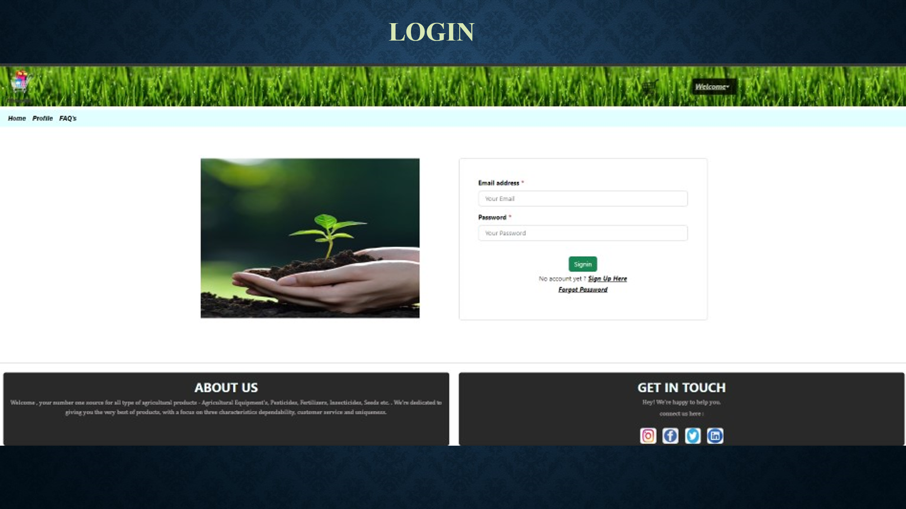

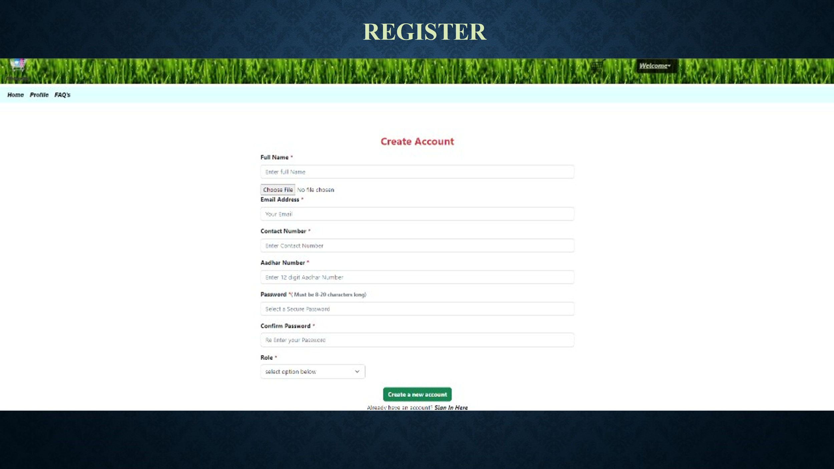

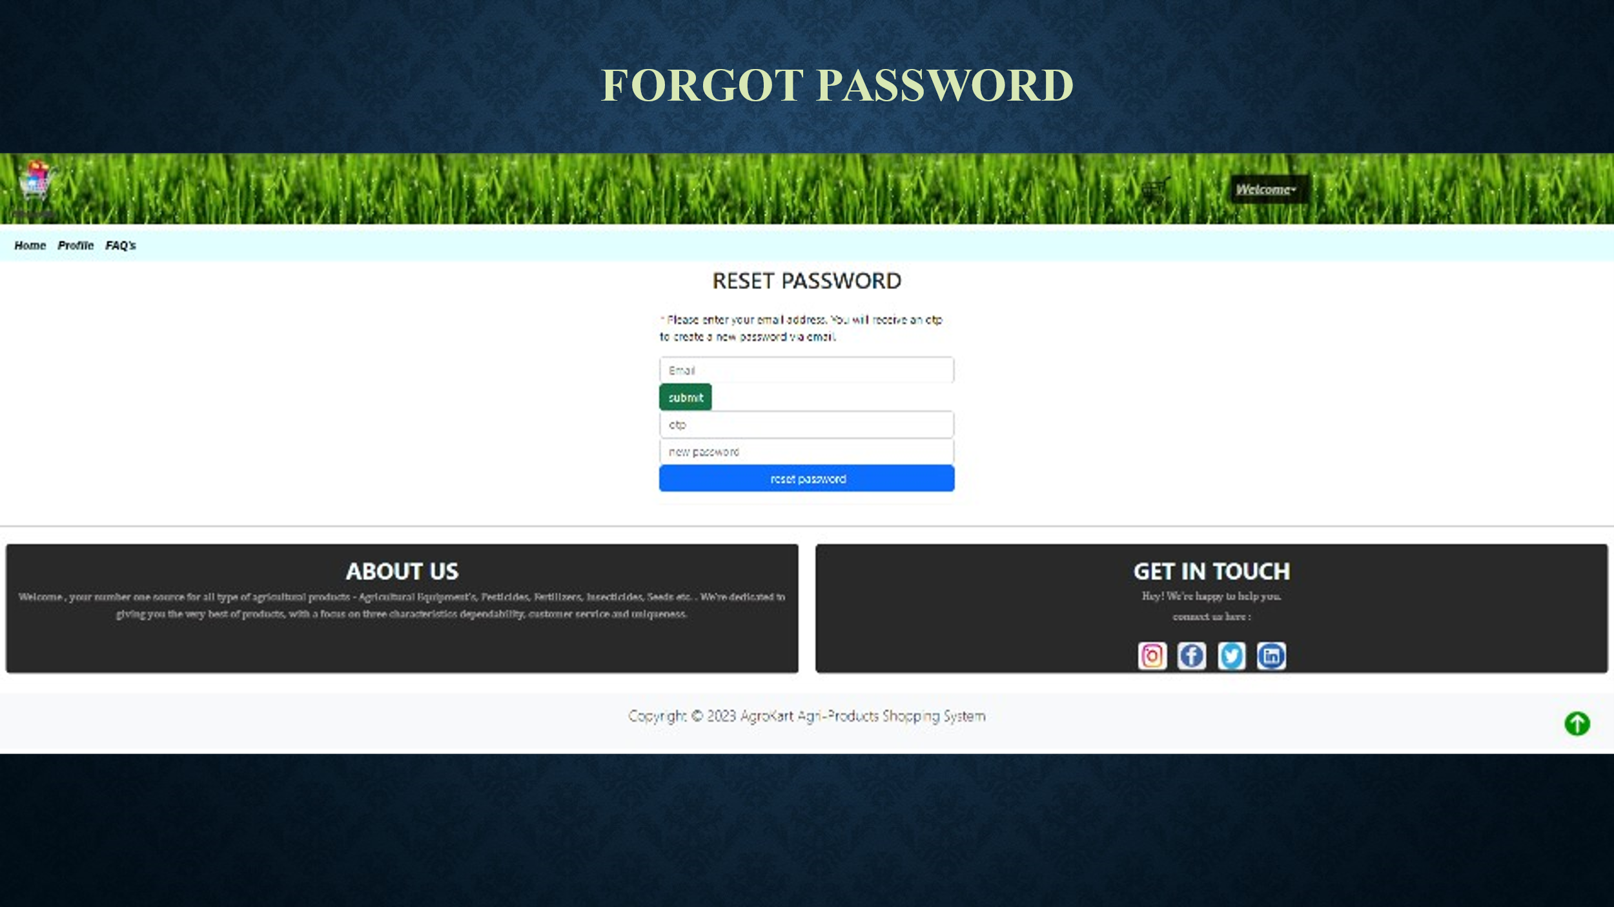

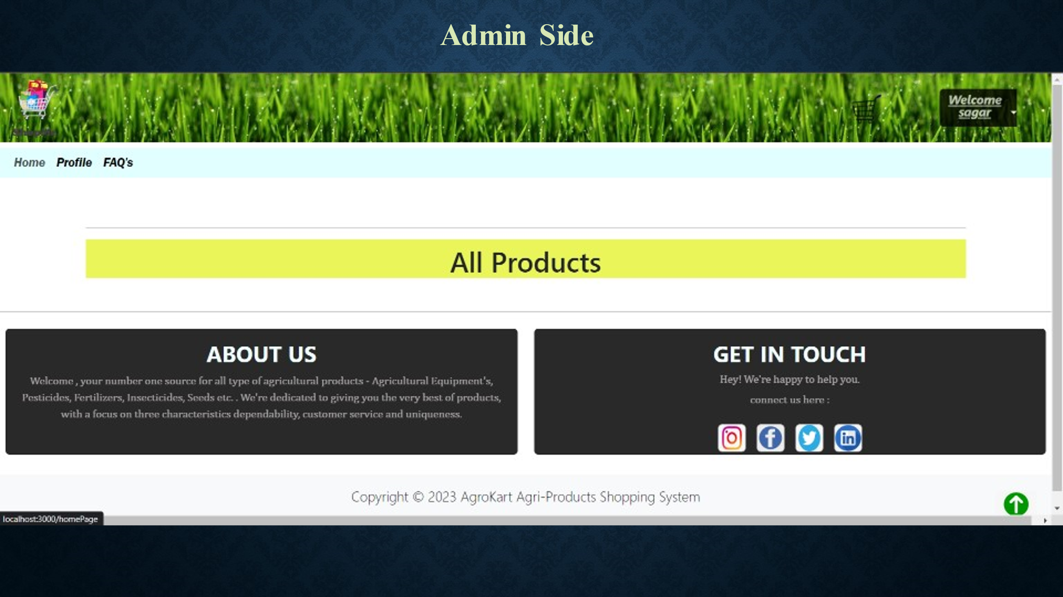

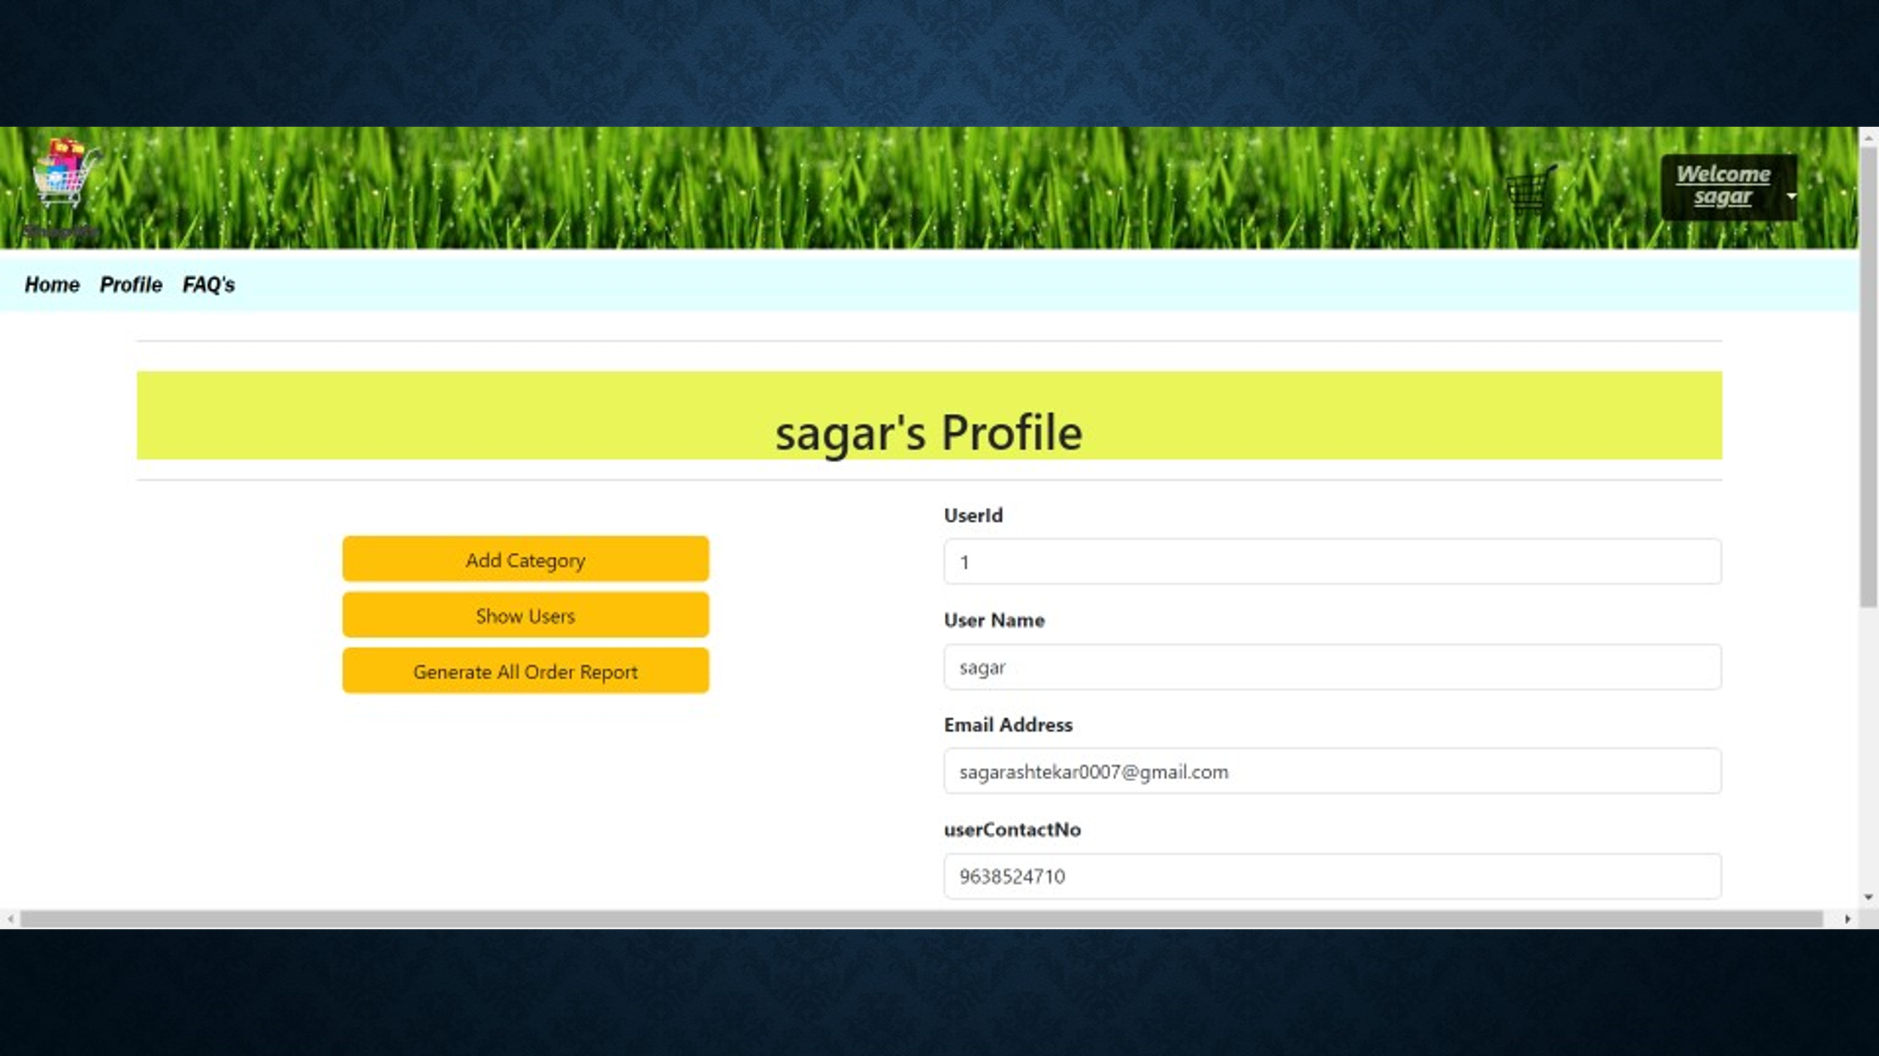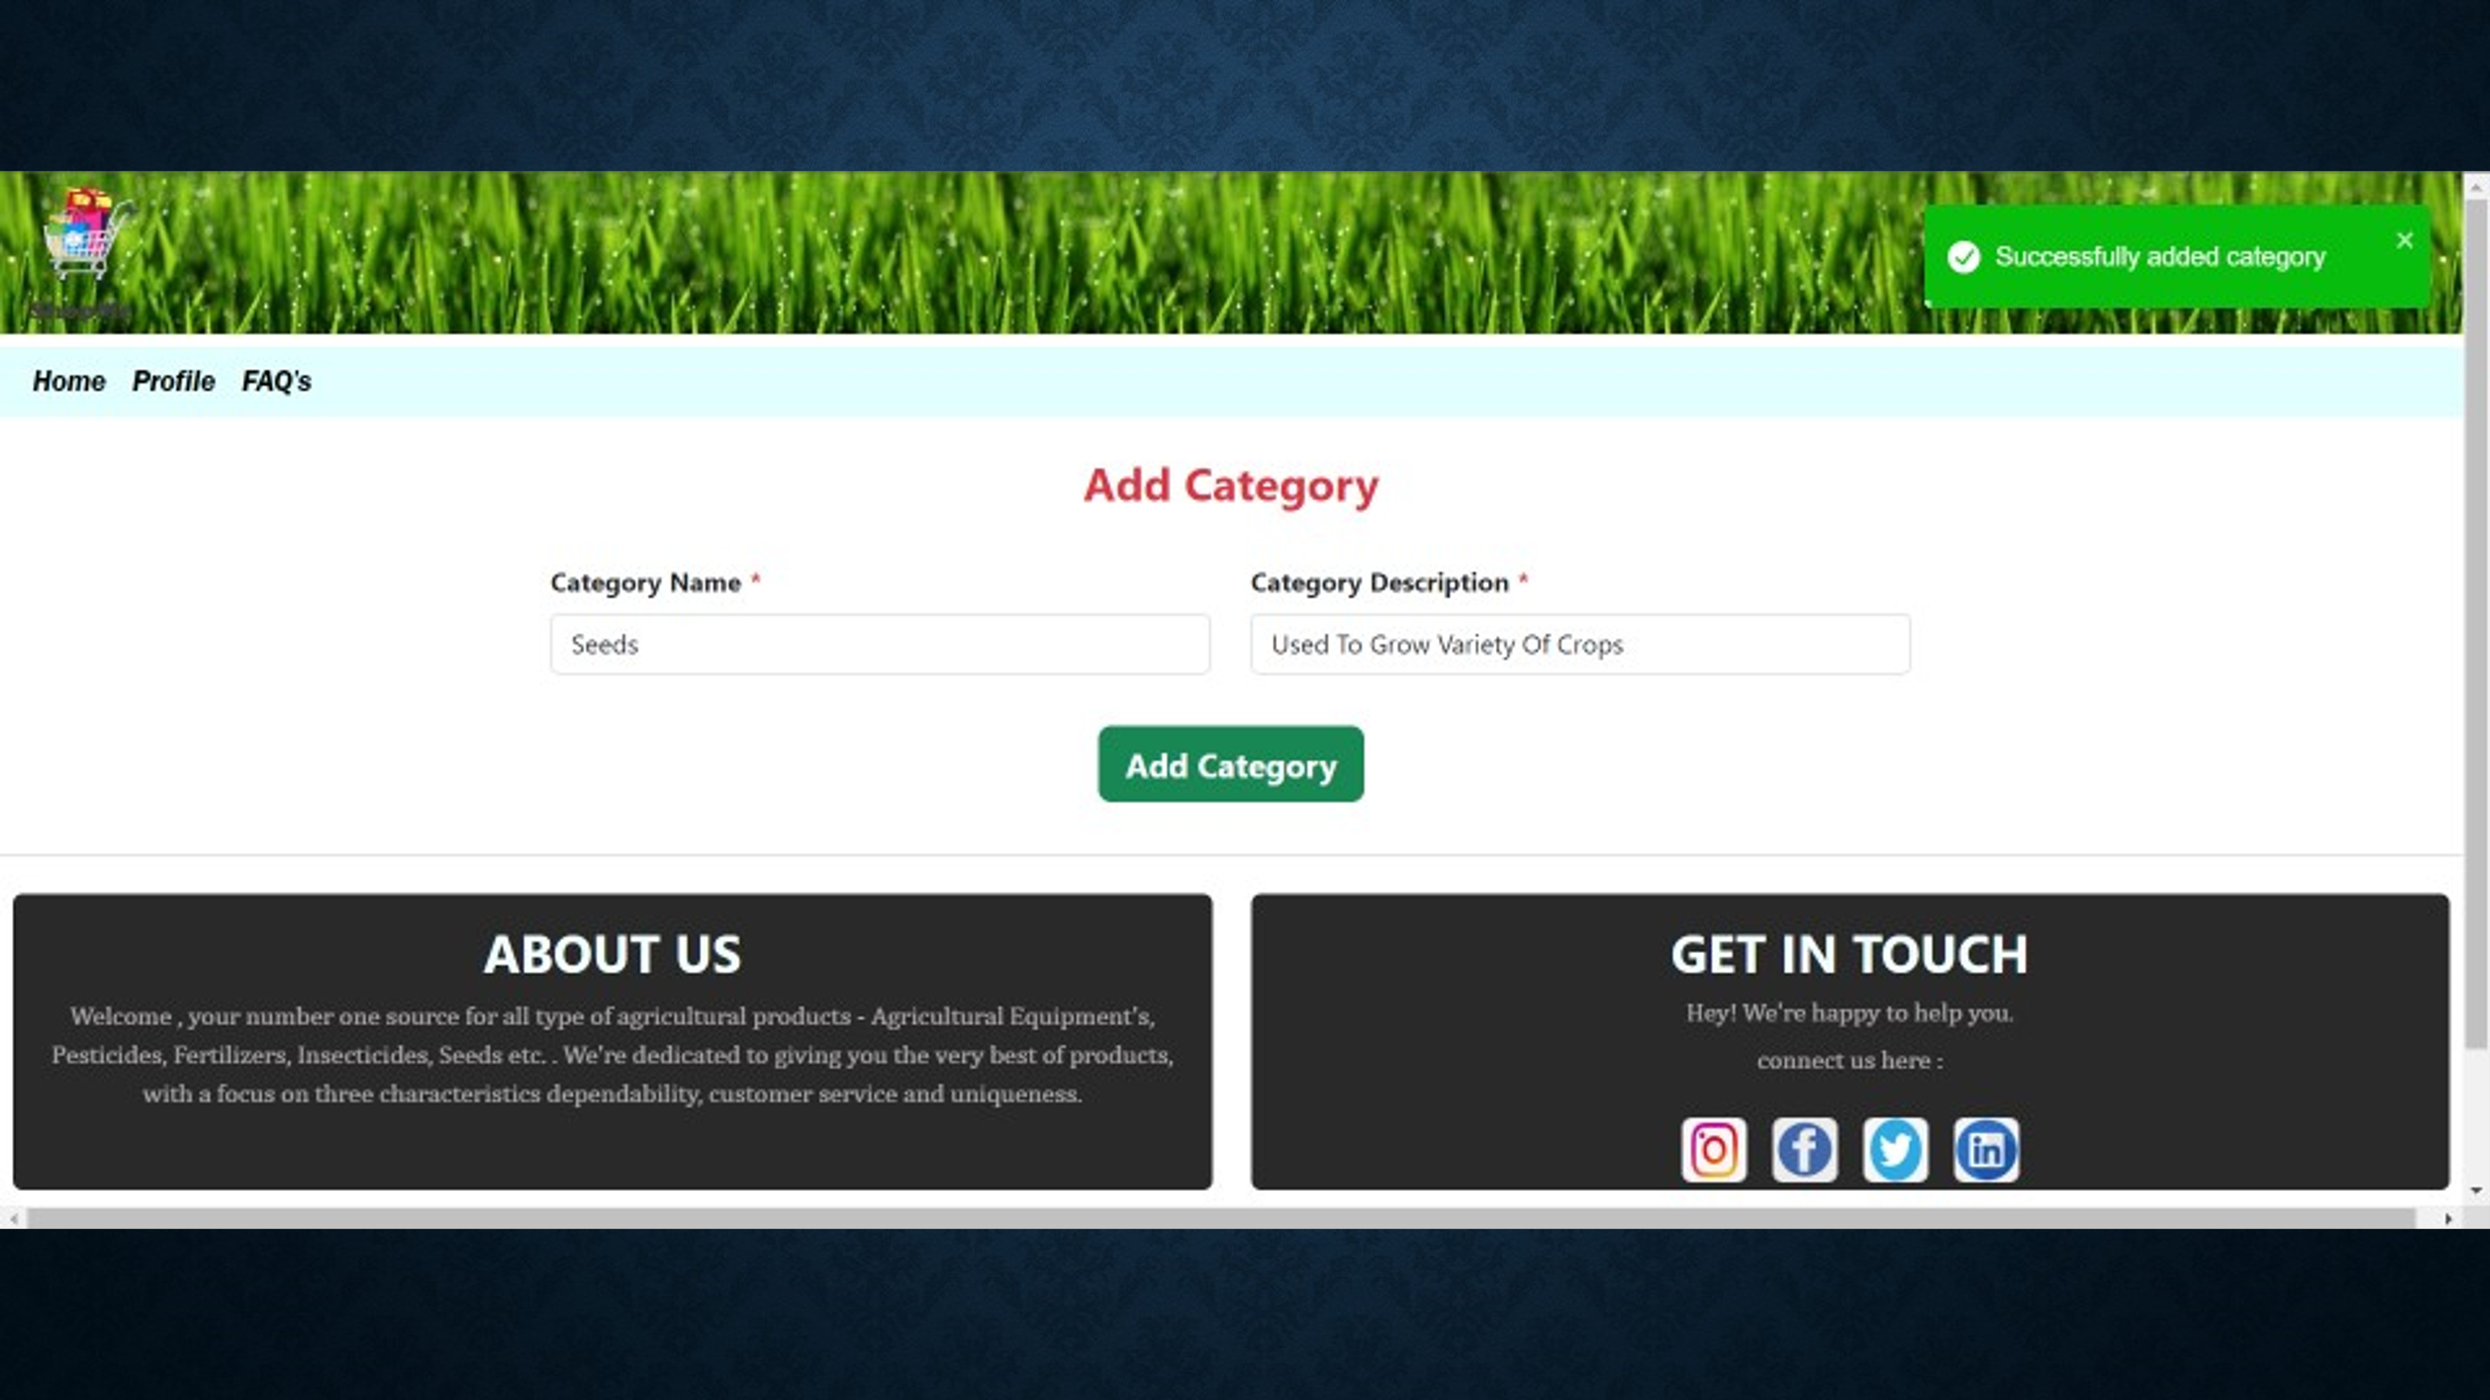

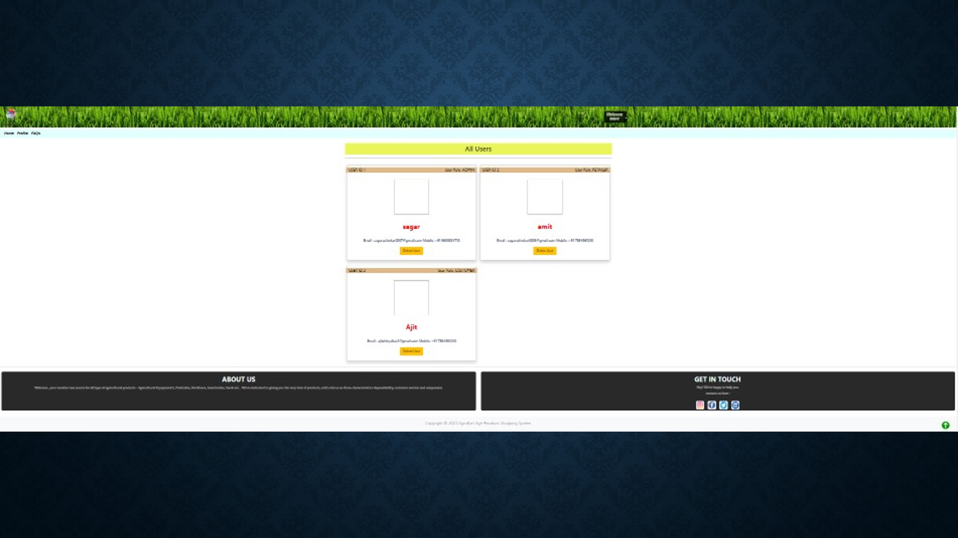

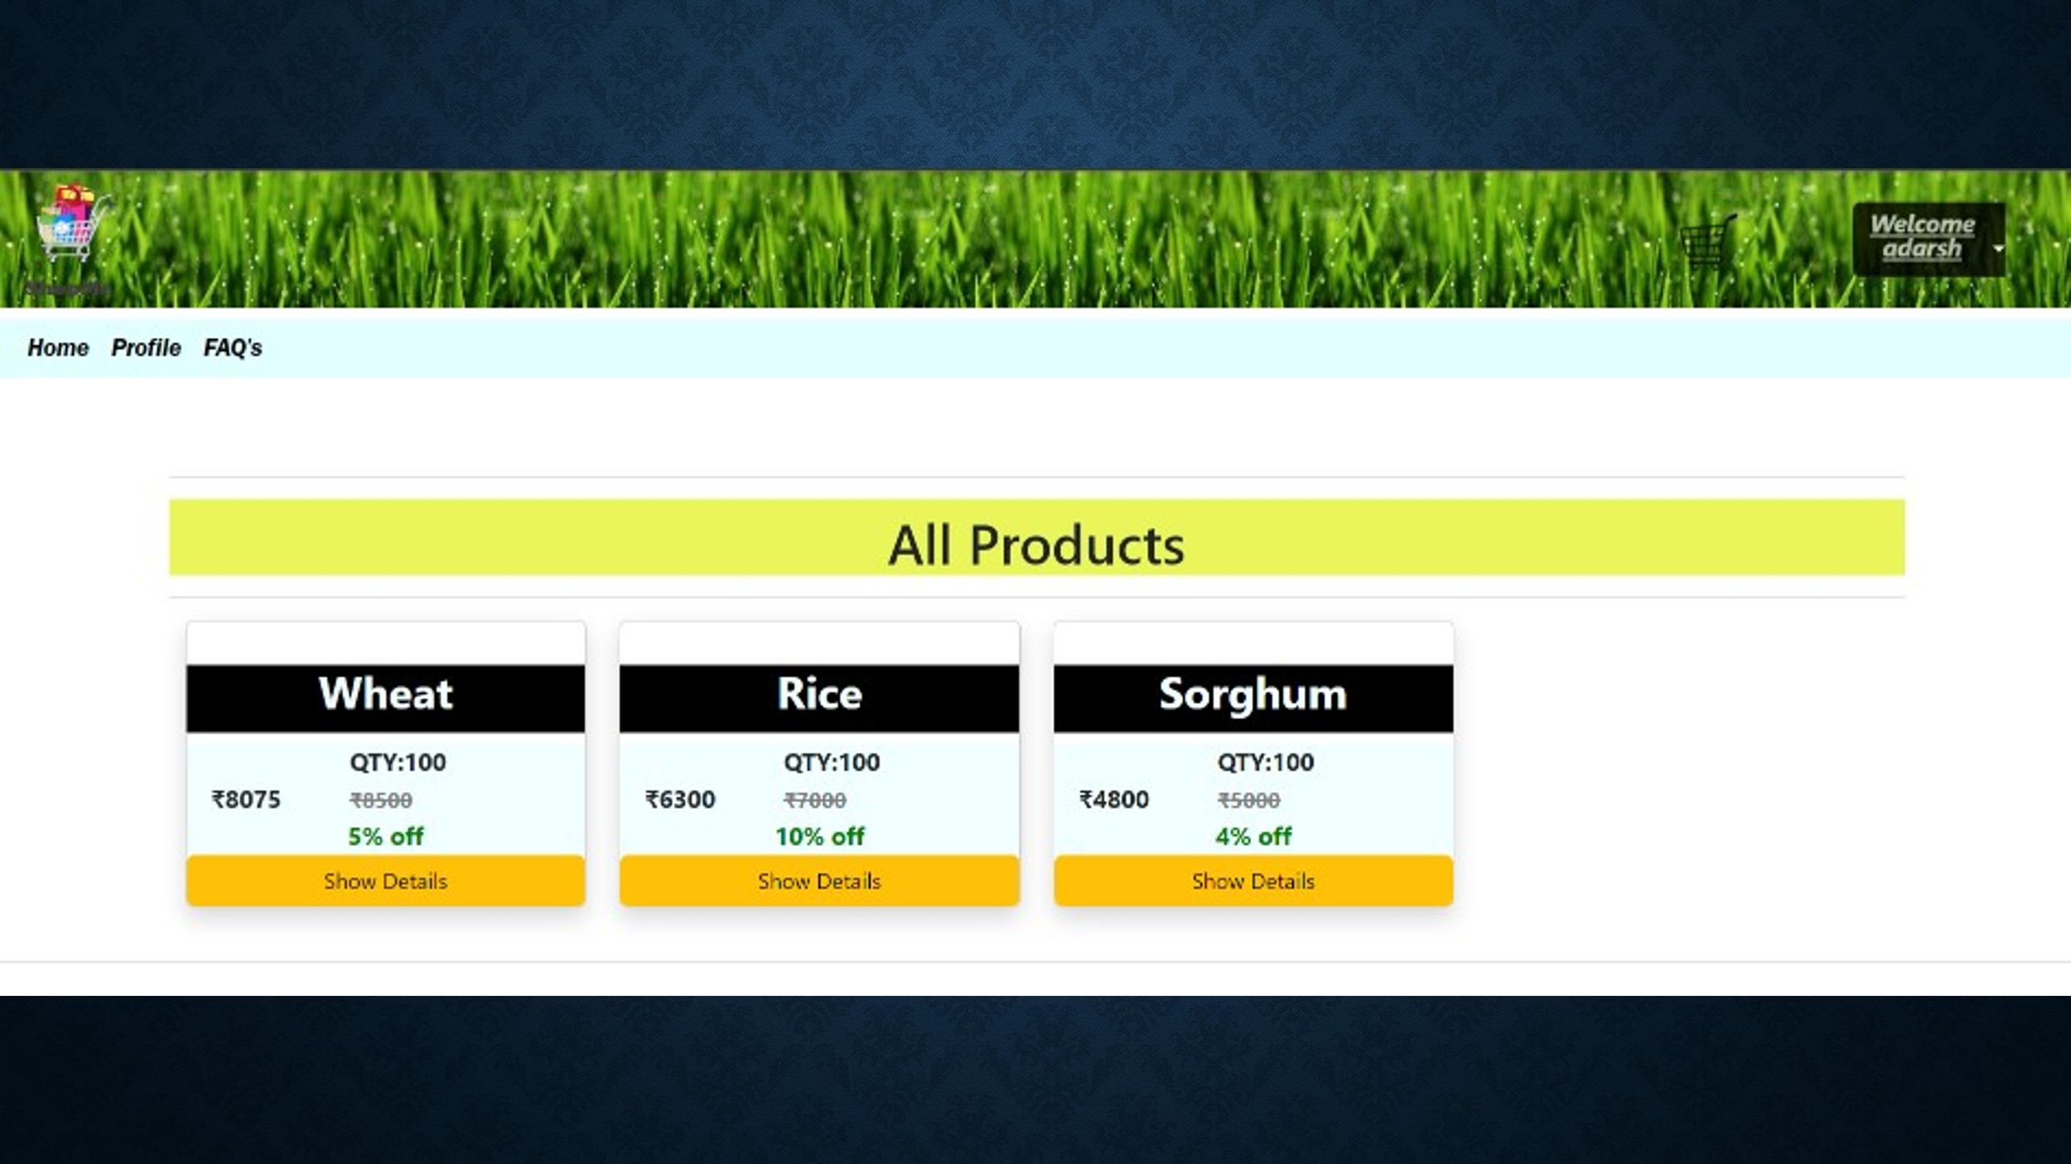

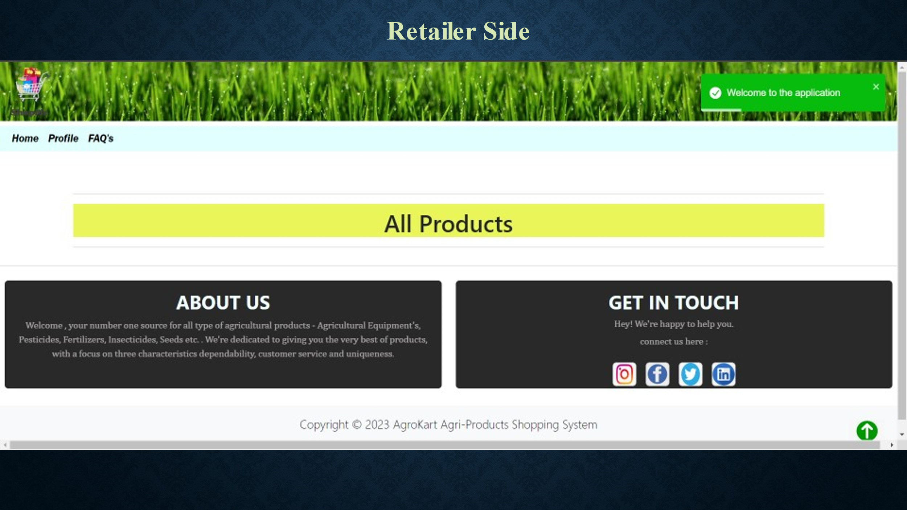

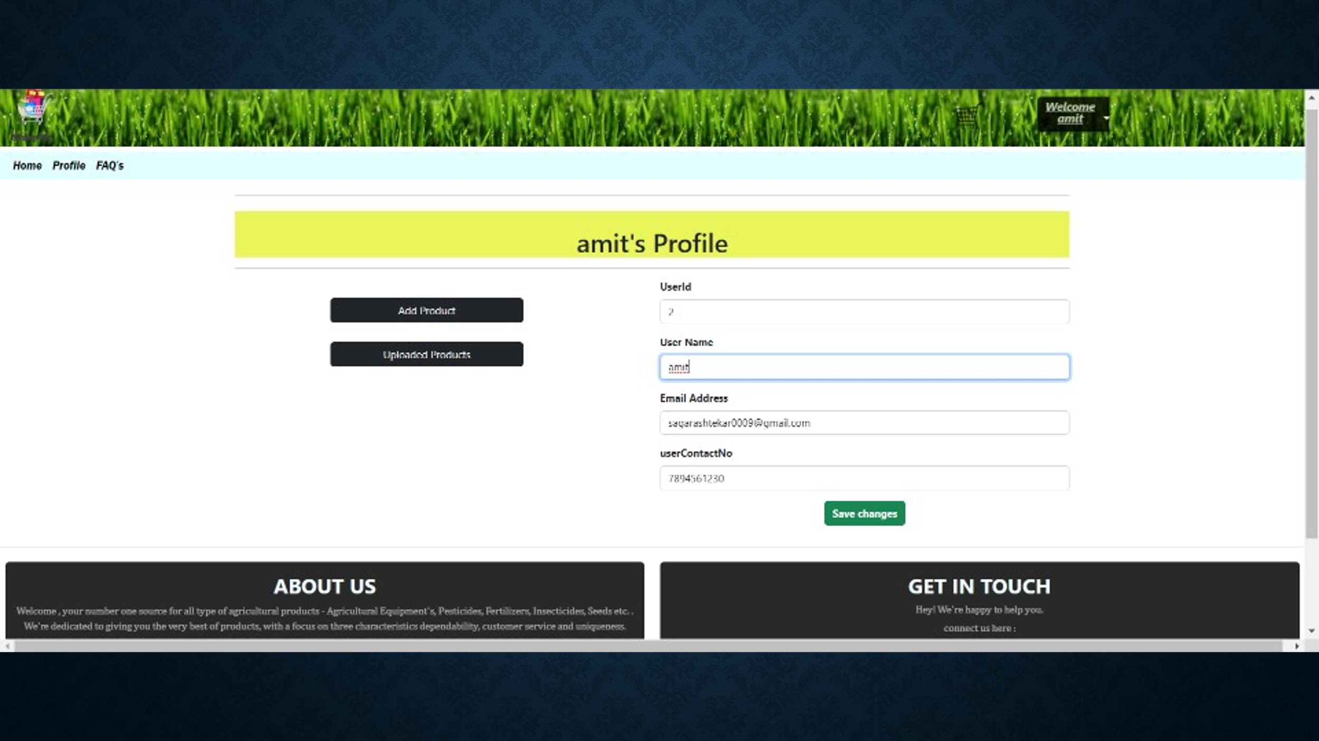

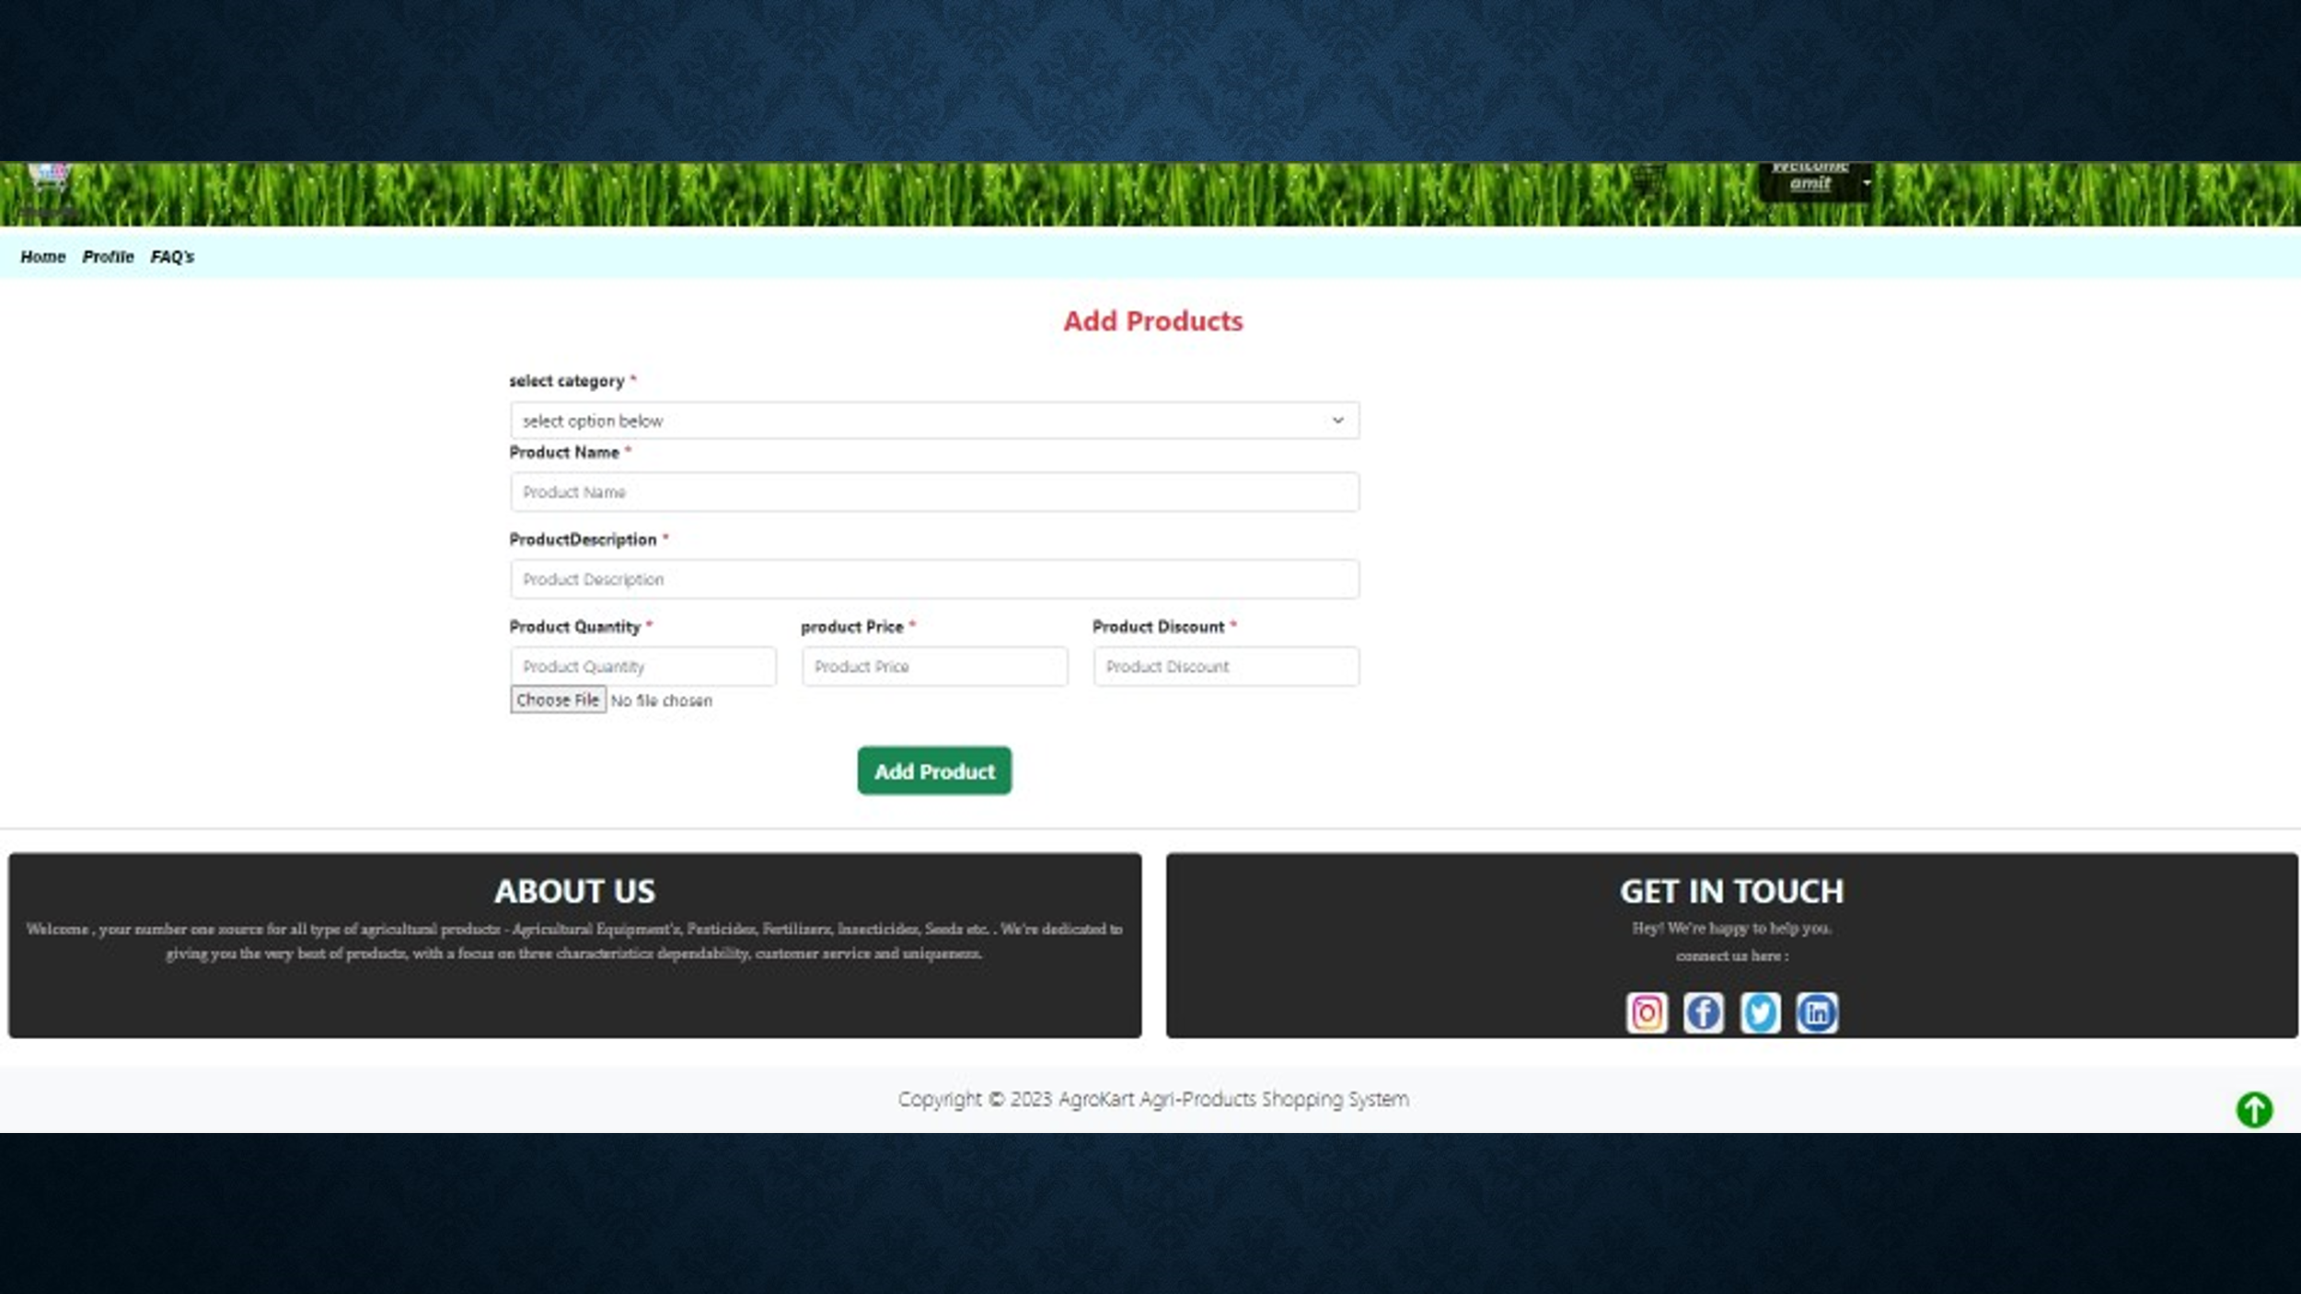

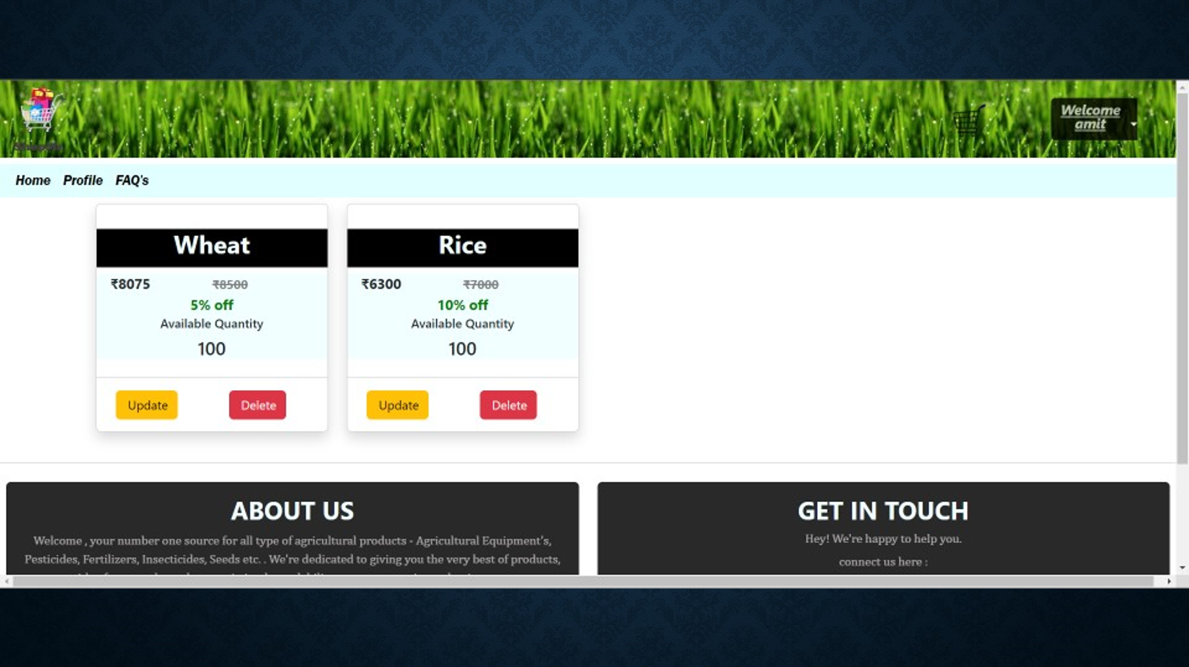

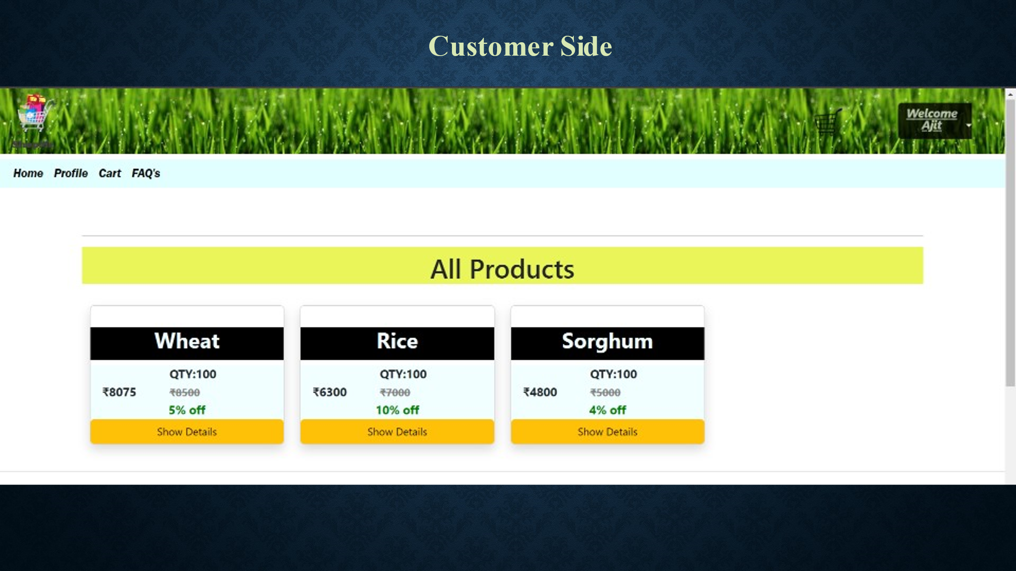

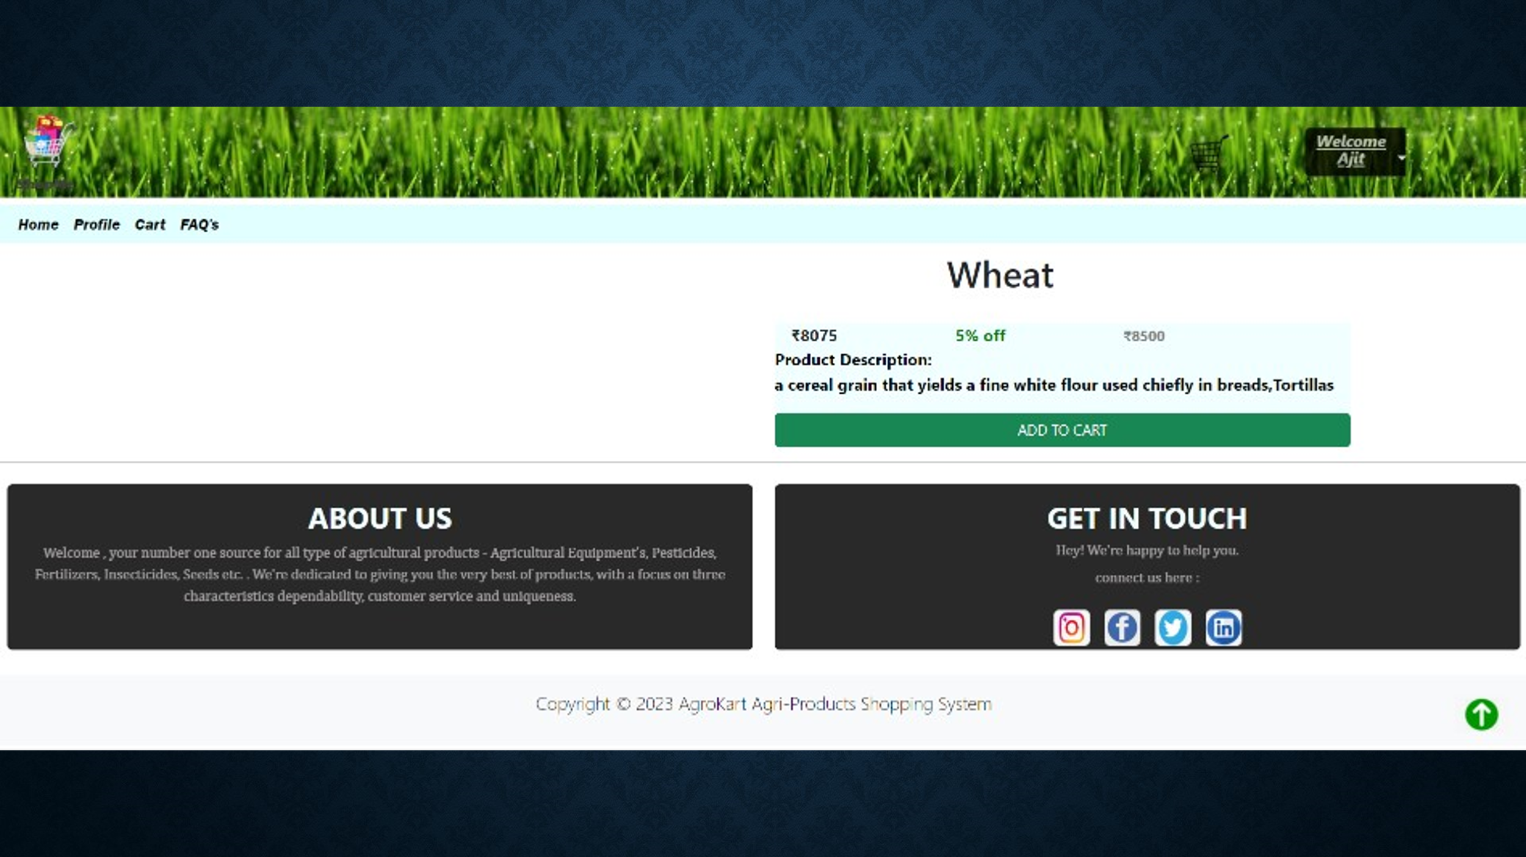

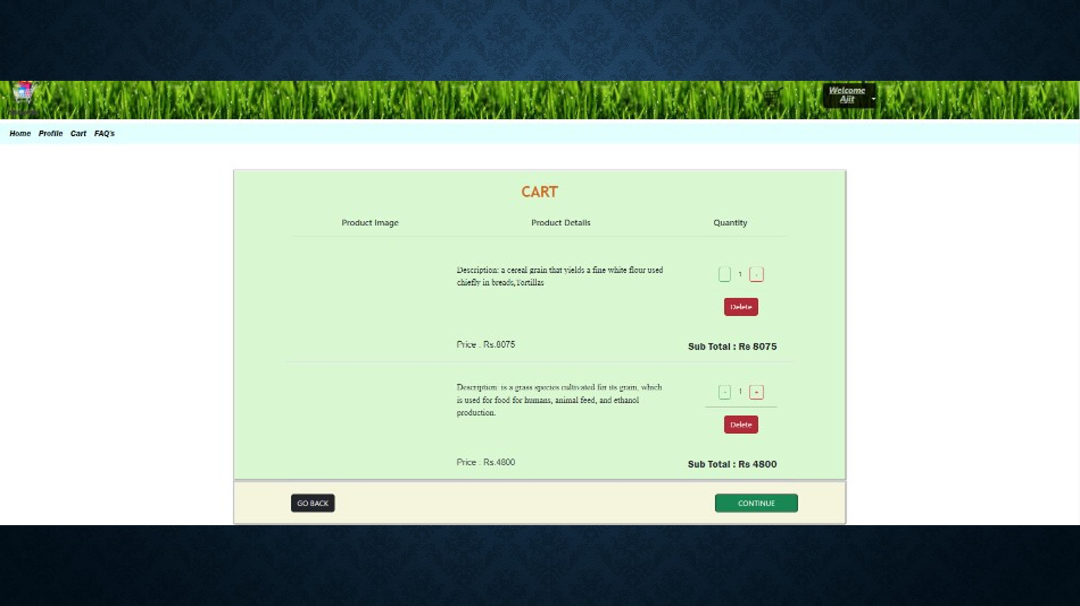

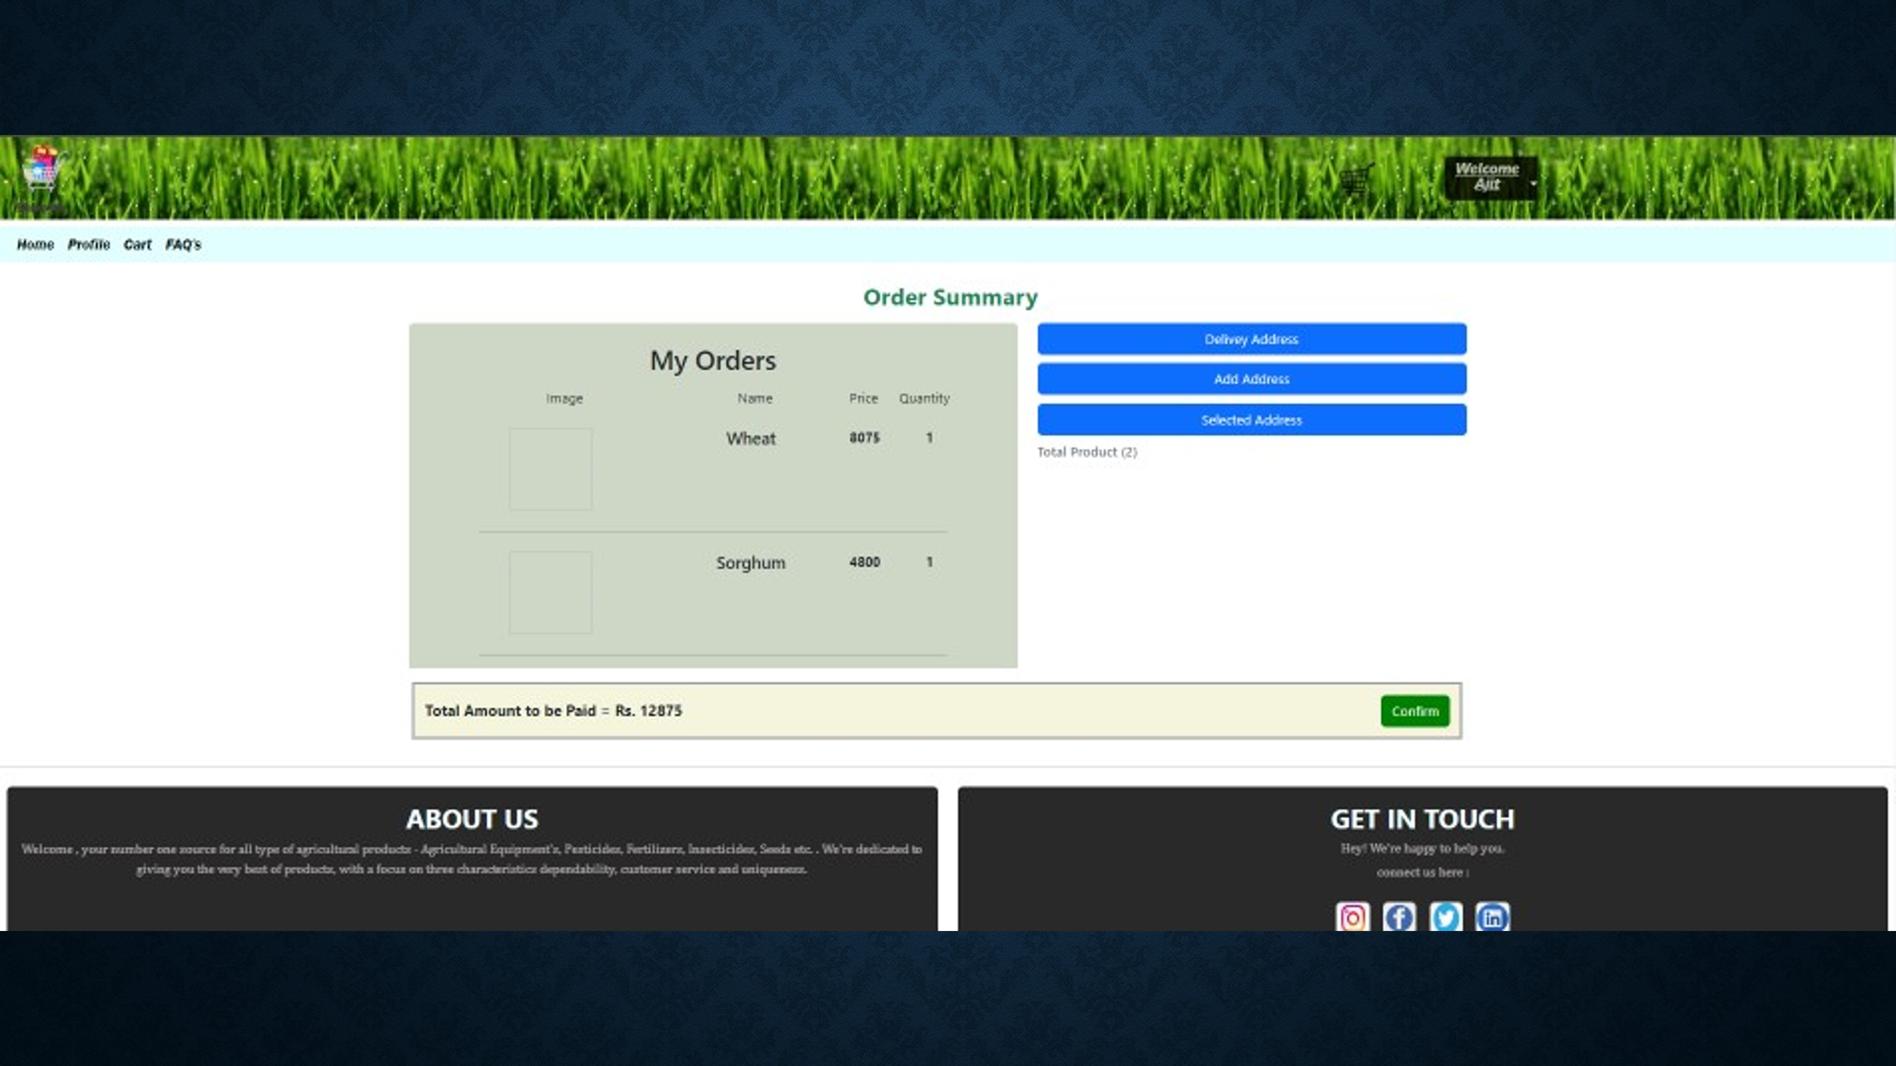

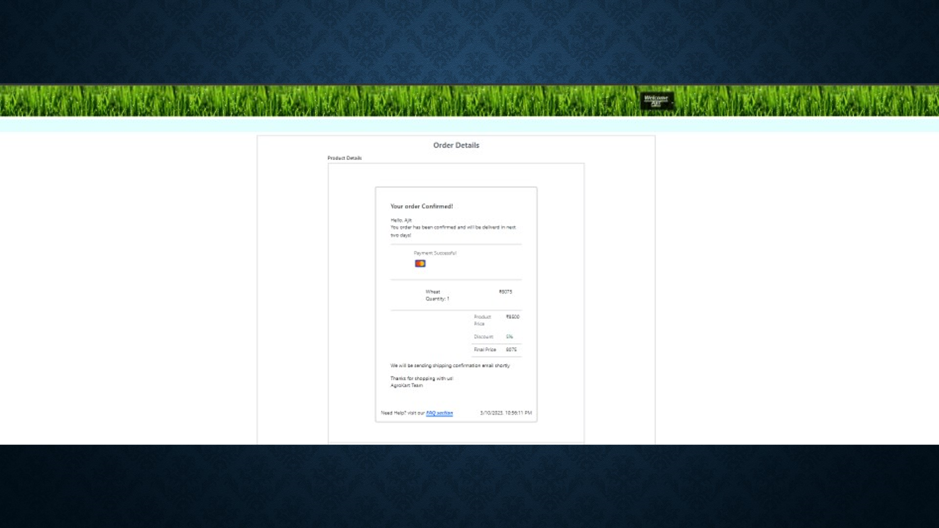

# DATABASE DESIGN

**DATABASE**

Databases are the storehouses of data used in the software systems. The data is stored in tables inside the database. Several tables are created for the manipulation of the data for the system. Two essential settings for a database are

* Primary key - the field that is unique for all the record occurrences
* Foreign key - the field used to set relation between tables Normalization is a technique to avoid redundancy in the tables.

**SYSTEM TOOLS**

The various system tools that have been used in developing both the front end and the back end of the project are being discussed in this chapter.

**FRONT END:**

React is a javaScript library which is developed by Facebook is design for development and design complex web application and are utilized to implement the frontend. React (also known as React.js or ReactJS) is a [free and open-source](https://en.wikipedia.org/wiki/Free_and_open-source_software) [front-end](https://en.wikipedia.org/wiki/Front_end_and_back_end) [JavaScript](https://en.wikipedia.org/wiki/JavaScript_library) [library](https://en.wikipedia.org/wiki/JavaScript_library) for building [user interfaces](https://en.wikipedia.org/wiki/User_interfaces) or UI components. It is maintained by [Facebook](https://en.wikipedia.org/wiki/Facebook%2C_Inc) and a community of individual developers and companies. React can be used as a base in the development of [single](https://en.wikipedia.org/wiki/Single-page_application) [page](https://en.wikipedia.org/wiki/Single-page_application) or mobile applications. However, React is only concerned with state management and rendering that state to the [DOM,](https://en.wikipedia.org/wiki/Document_Object_Model) so creating React applications usually requires the use of additional libraries for routing, as well as certain client-side functionality.

**BACKEND:**

The back end is implemented using MySQL which is used to design databases.

**MySQL:**

MySQL is the world's second most widely used open-source relational database management system (RDBMS). The SQL phrase stands for Structured Query Language. An application software called Navicert was used to design the tables in MySQL.

**Spring-Boot:**

This is used to connect MYSQL and fetch data from database and store the data in database. The Spring Framework is a[n application framework](https://en.wikipedia.org/wiki/Application_framework) and [inversion of control](https://en.wikipedia.org/wiki/Inversion_of_control) [container](https://en.wikipedia.org/wiki/Servlet_container) for the [Java](https://en.wikipedia.org/wiki/Java_platform) [platform.](https://en.wikipedia.org/wiki/Java_platform) The framework's core features can be used by any Java application, but there are extensions for building web applications on top of the [Java EE](https://en.wikipedia.org/wiki/Java_EE) (Enterprise Edition) platform. Although the framework does not impose any specific [programming model,](https://en.wikipedia.org/wiki/Programming_model) it has become popular in the Java community as an addition to the [Enterprise JavaBeans](https://en.wikipedia.org/wiki/Enterprise_JavaBeans) (EJB) model. The Spring Framework is Open-source Framework

**8.. CONCLUSION AND FUTURE SCOPE**

Online shopping of agriculture product increases the scope of small farmers by directly selling their product online and gives the best price for their product. Also Farmer as Customer can buy there required product with correct price and required quantity at required time.

Our System provides a very user-friendly platform for Buying and Selling with specific categories for specific products and also Farmer as Customer can get discount on some products .Buyer can select both cash on delivery and online mode of payment .

All authenticated users can able to access their accounts and able to perform different functionalities according to their role.

# REFERENCES

http://www.google.com

https://agritech.tnau.ac.in/

https://farmer.gov.in/

https://en.wikipedia.org/wiki/Agriculture

https://www.geeksforgeeks.org/java/